Test Case: tc001_SPX_Dev5_Crear_Requisicion_Spot_Tipo_Cobro_CC
Step 1 - Enter username and password and click to button Enter : Credentials Entered
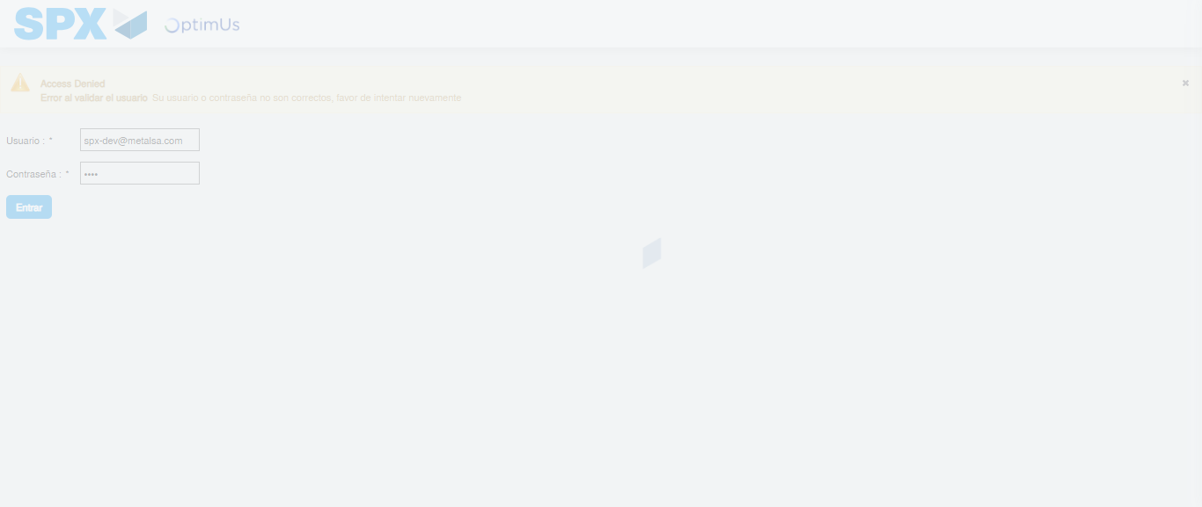Image file-name: QC_Testing-tc001_SPX_Dev5_Crear_Requisicion_Spot_Tipo_Cobro_CC-1783978683870

Step 2 - Select to UEN and Access to Spot Buy Requisitions : UEN Correctly selected and Correct access
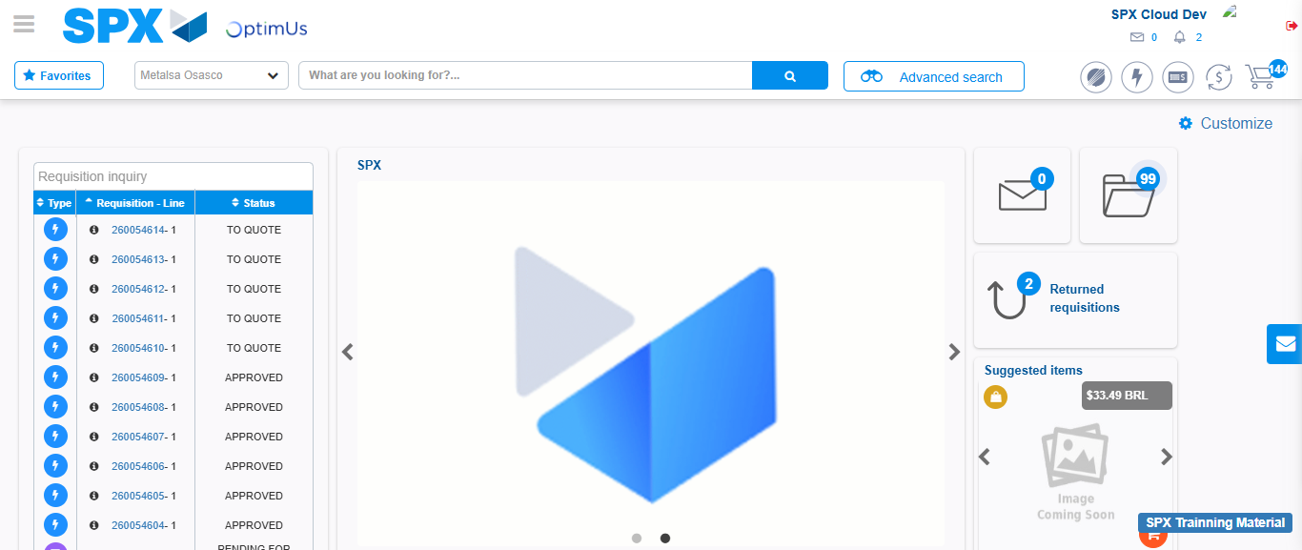Image file-name: QC_Testing-tc001_SPX_Dev5_Crear_Requisicion_Spot_Tipo_Cobro_CC-1783978749113

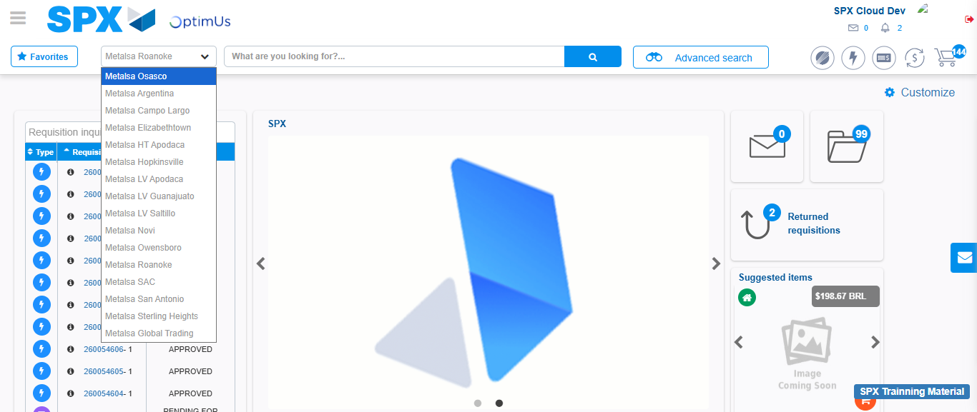Image file-name: QC_Testing-tc001_SPX_Dev5_Crear_Requisicion_Spot_Tipo_Cobro_CC-1783978751861

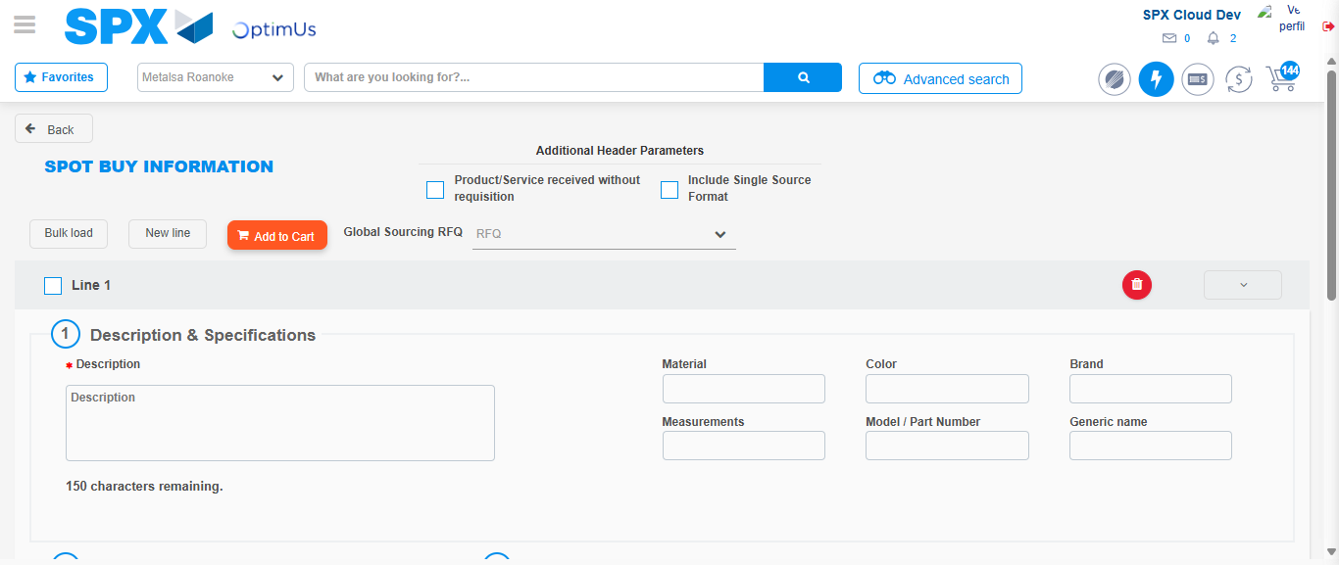Image file-name: QC_Testing-tc001_SPX_Dev5_Crear_Requisicion_Spot_Tipo_Cobro_CC-1783978758988

Step 3 - Data Capture Spot Buy Requisition : Data captured correctly
Image file-name: QC_Testing-tc001_SPX_Dev5_Crear_Requisicion_Spot_Tipo_Cobro_CC-1783978759222

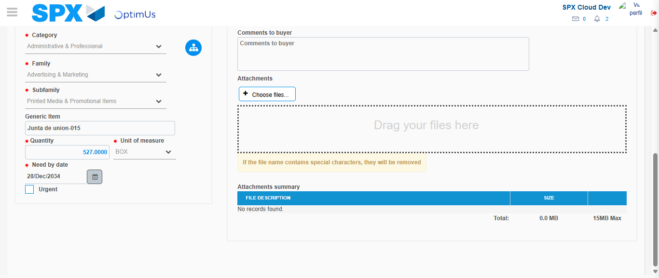Image file-name: QC_Testing-tc001_SPX_Dev5_Crear_Requisicion_Spot_Tipo_Cobro_CC-1783978769897

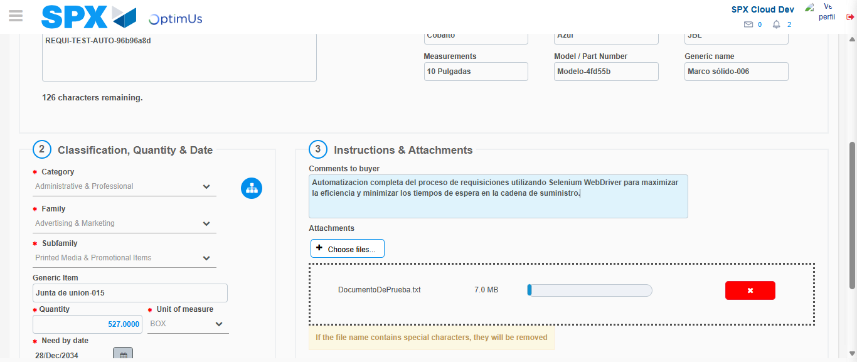Image file-name: QC_Testing-tc001_SPX_Dev5_Crear_Requisicion_Spot_Tipo_Cobro_CC-1783978770657

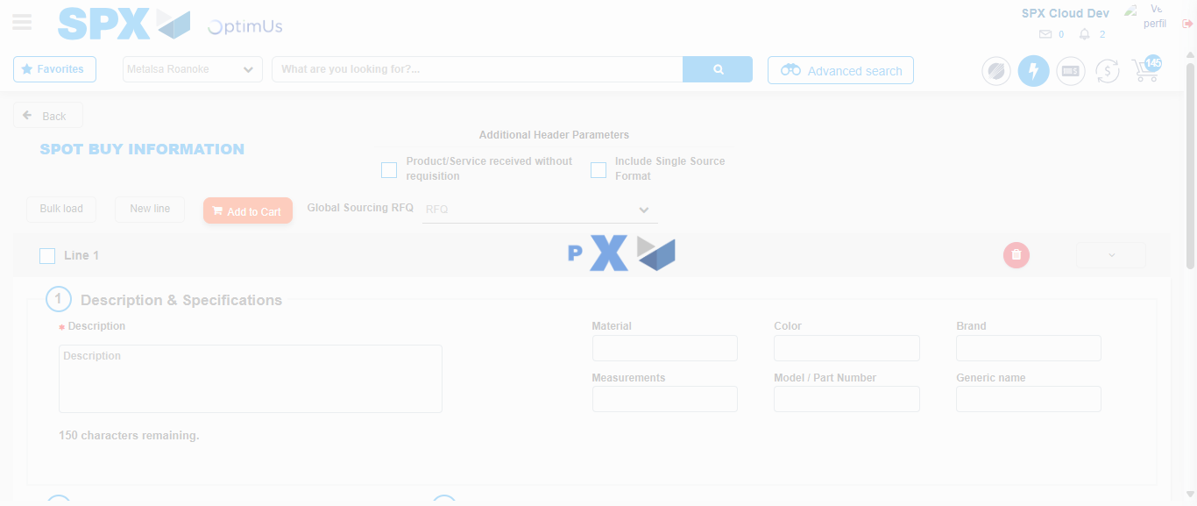Image file-name: QC_Testing-tc001_SPX_Dev5_Crear_Requisicion_Spot_Tipo_Cobro_CC-1783978776670

Step 7 - Return to Main Page SPX : Return to Main Page SPX
Image file-name: QC_Testing-tc001_SPX_Dev5_Crear_Requisicion_Spot_Tipo_Cobro_CC-1783978749113

Image file-name: QC_Testing-tc001_SPX_Dev5_Crear_Requisicion_Spot_Tipo_Cobro_CC-1783978751861

Image file-name: QC_Testing-tc001_SPX_Dev5_Crear_Requisicion_Spot_Tipo_Cobro_CC-1783978758988

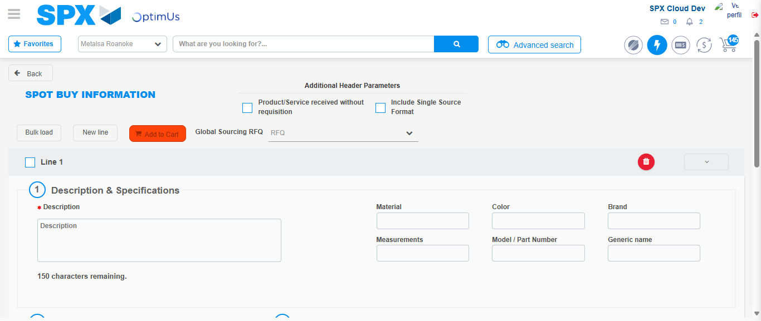Image file-name: QC_Testing-tc001_SPX_Dev5_Crear_Requisicion_Spot_Tipo_Cobro_CC-1783978778905

Image file-name: QC_Testing-tc001_SPX_Dev5_Crear_Requisicion_Spot_Tipo_Cobro_CC-1783978779067

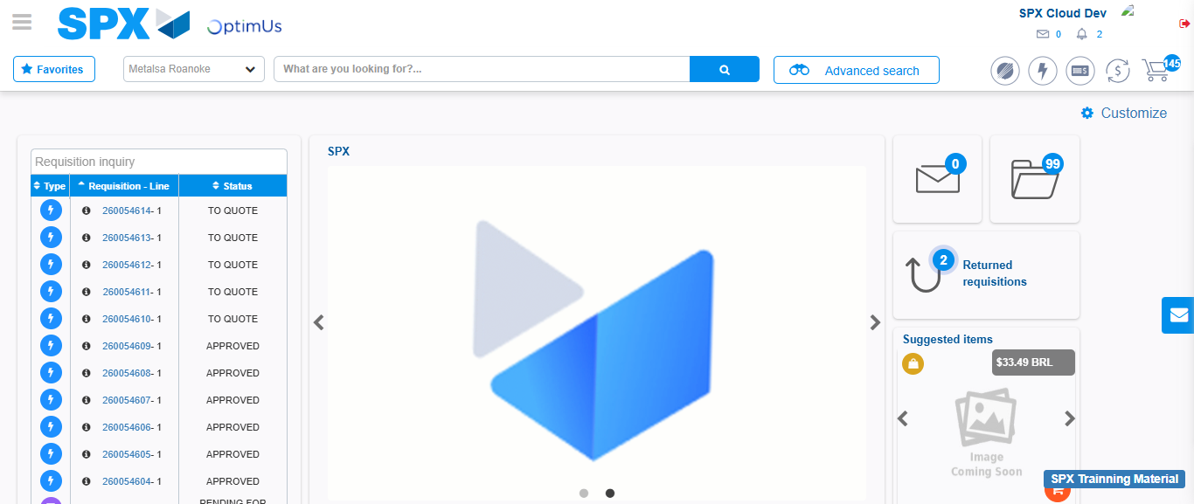Image file-name: QC_Testing-tc001_SPX_Dev5_Crear_Requisicion_Spot_Tipo_Cobro_CC-1783978800096

Step 8 - Log Out : Log Out SPX
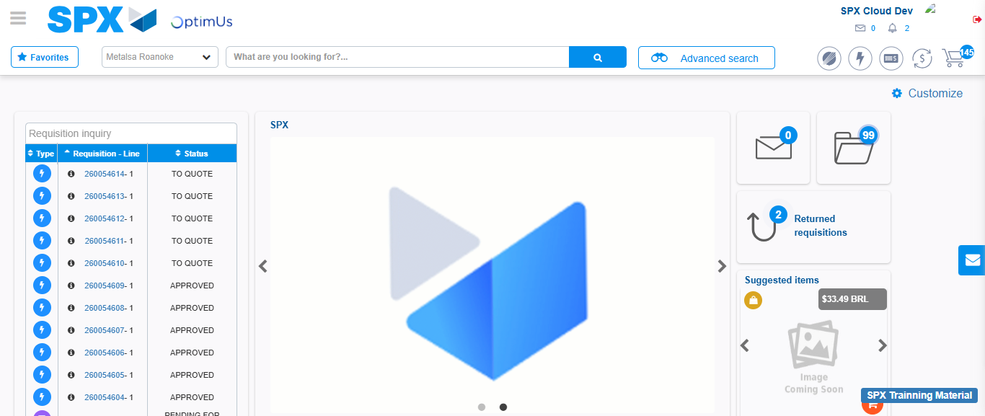Image file-name: QC_Testing-tc001_SPX_Dev5_Crear_Requisicion_Spot_Tipo_Cobro_CC-1783978800411

